ANALYSIS REPORT

BIBIN T S

DA - 39

Dataset Link
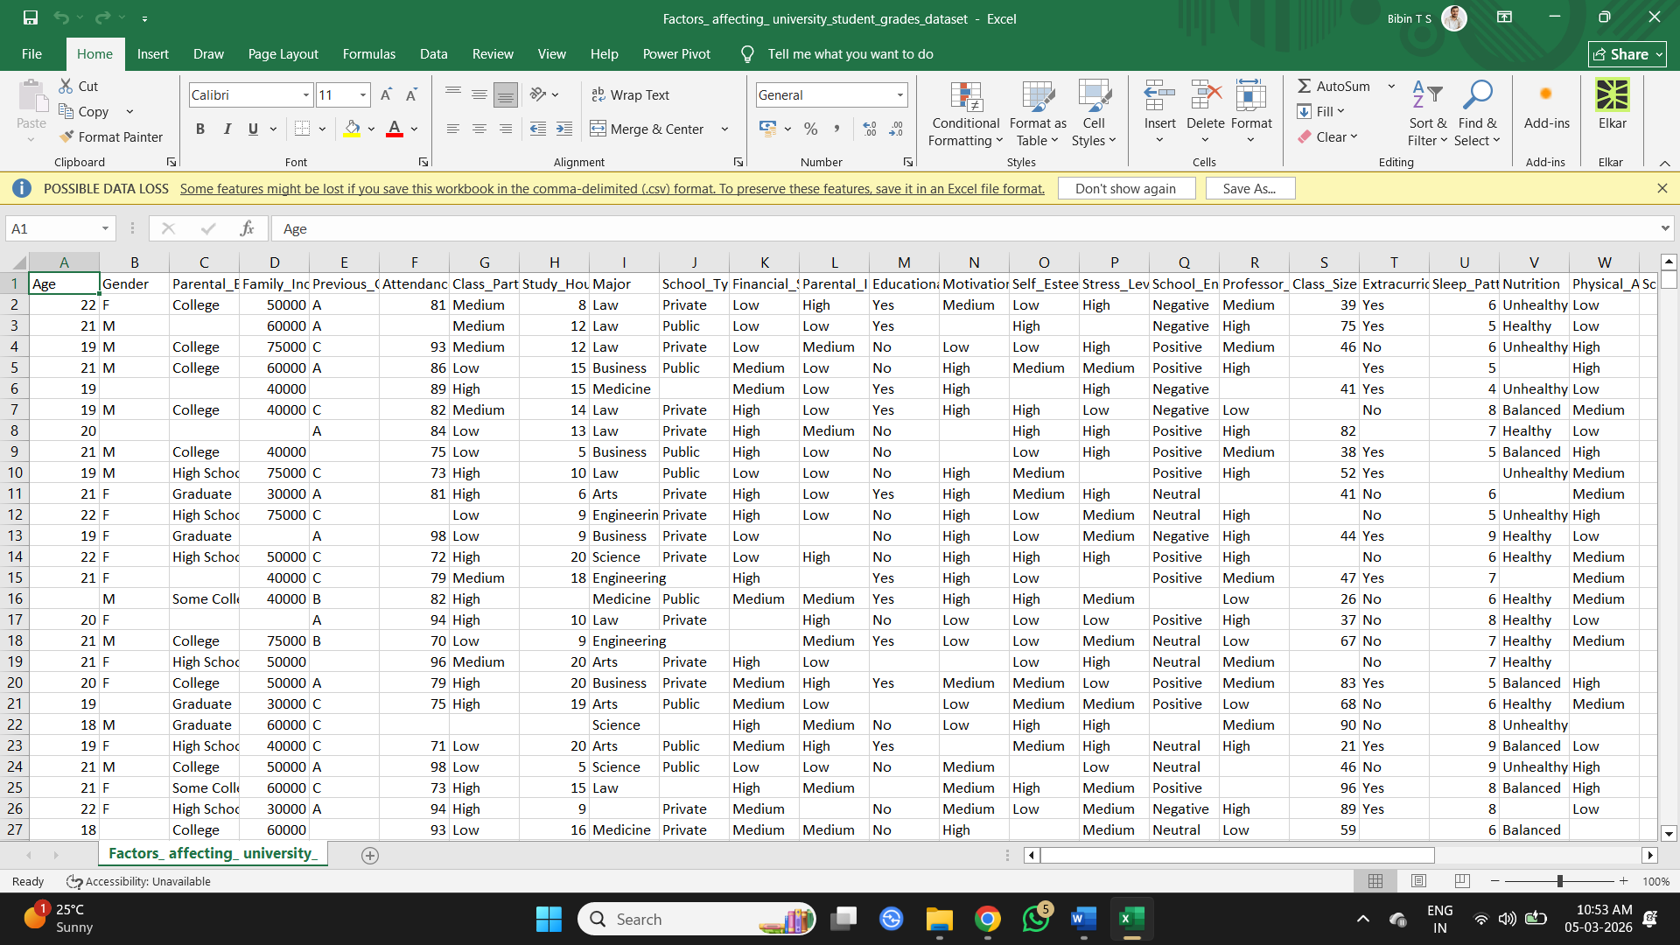
Figure 1 - Raw dataset

OBJECTIVE
This project aims to analyze university student data to understand how factors such as study habits, lifestyle, academic environment, and engagement influence student academic performance. The analysis helps identify key factors that affect student grades and provides insights into patterns related to student success.

DATASET DESCRIPTION
The dataset used in this project contains information about university students and various factors that may influence student academic performance. It includes demographic details, academic habits, lifestyle factors, and support systems such as tutoring and mentoring. The dataset contains variables such as age, gender, study hours, attendance, family income, parental education, social media usage, sports participation, and previous grades.

DATA PRE-PROCESSING USING EXCEL
Before performing analysis and visualization, the dataset was cleaned and prepared using Microsoft Excel. Data preprocessing was carried out to handle missing values, ensure consistent formatting, and transform the dataset into a structure suitable for analysis.

- Importing the Dataset into Excel
The dataset was downloaded in CSV format and imported into Microsoft Excel. The structure of the dataset, including columns and records, was reviewed before beginning the preprocessing steps.
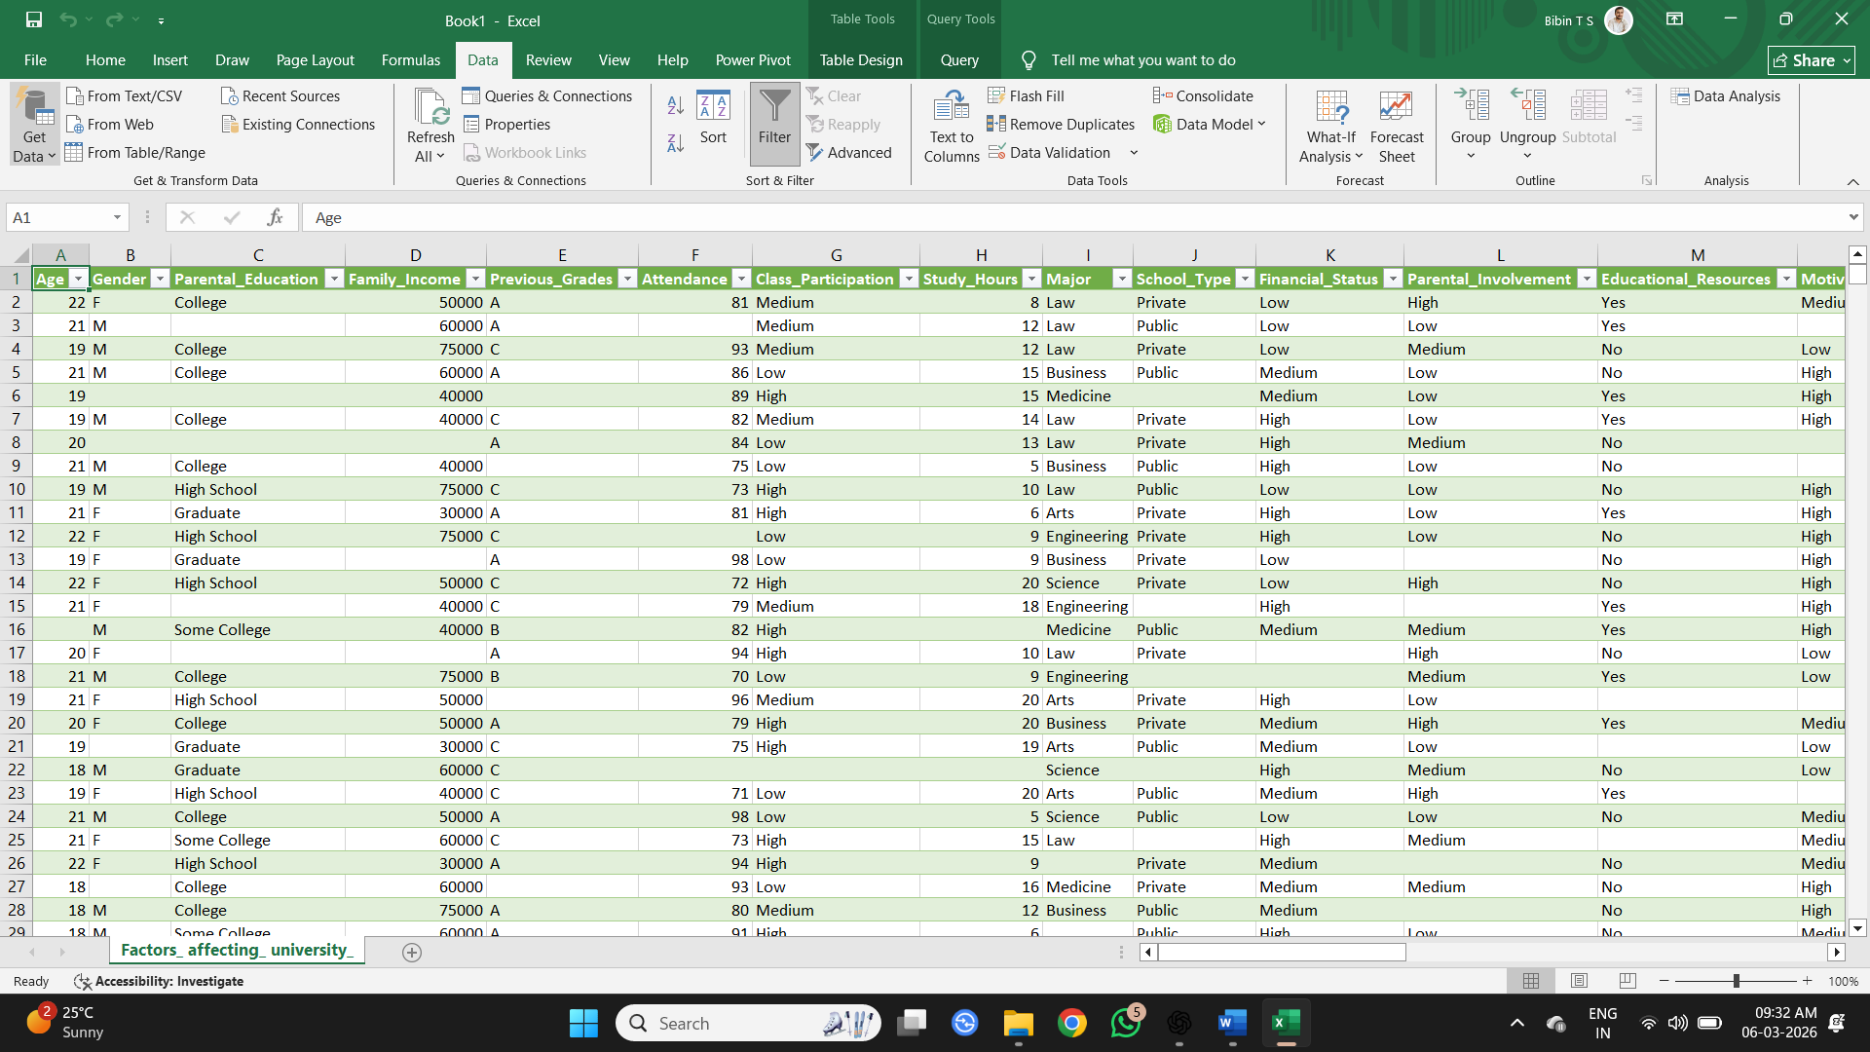
Figure 2 - Imported Dataset

- Checking and Removing Duplicate Records
The dataset was checked for duplicate entries using Excel’s Remove Duplicates feature. This step ensured that each student record in the dataset was unique. No duplicate records were identified in the dataset.
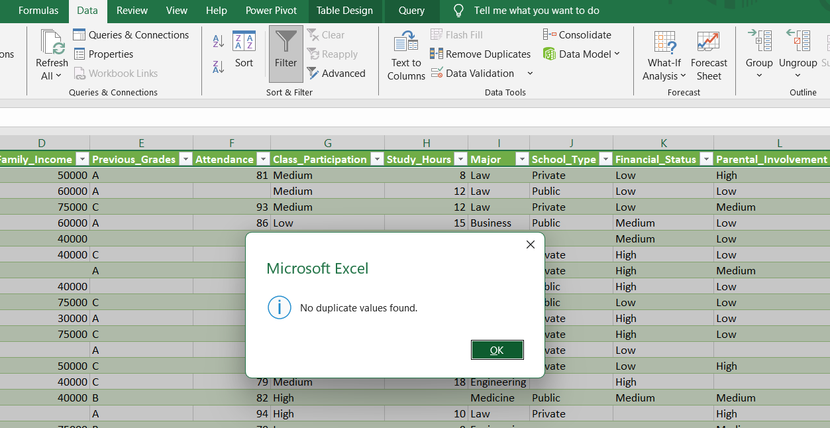
Figure 3 - Checking for Duplicates

- Handling Missing Values
The dataset contained missing values across several columns. These were identified using Excel’s filtering tools. Missing values in categorical columns such as gender, school type, and tutoring were replaced with “Unknown” to maintain data consistency. Missing values in numerical columns such as age, study hours, attendance, and grades were replaced using the average value of the respective column. This approach ensured that the dataset remained complete and suitable for further analysis.
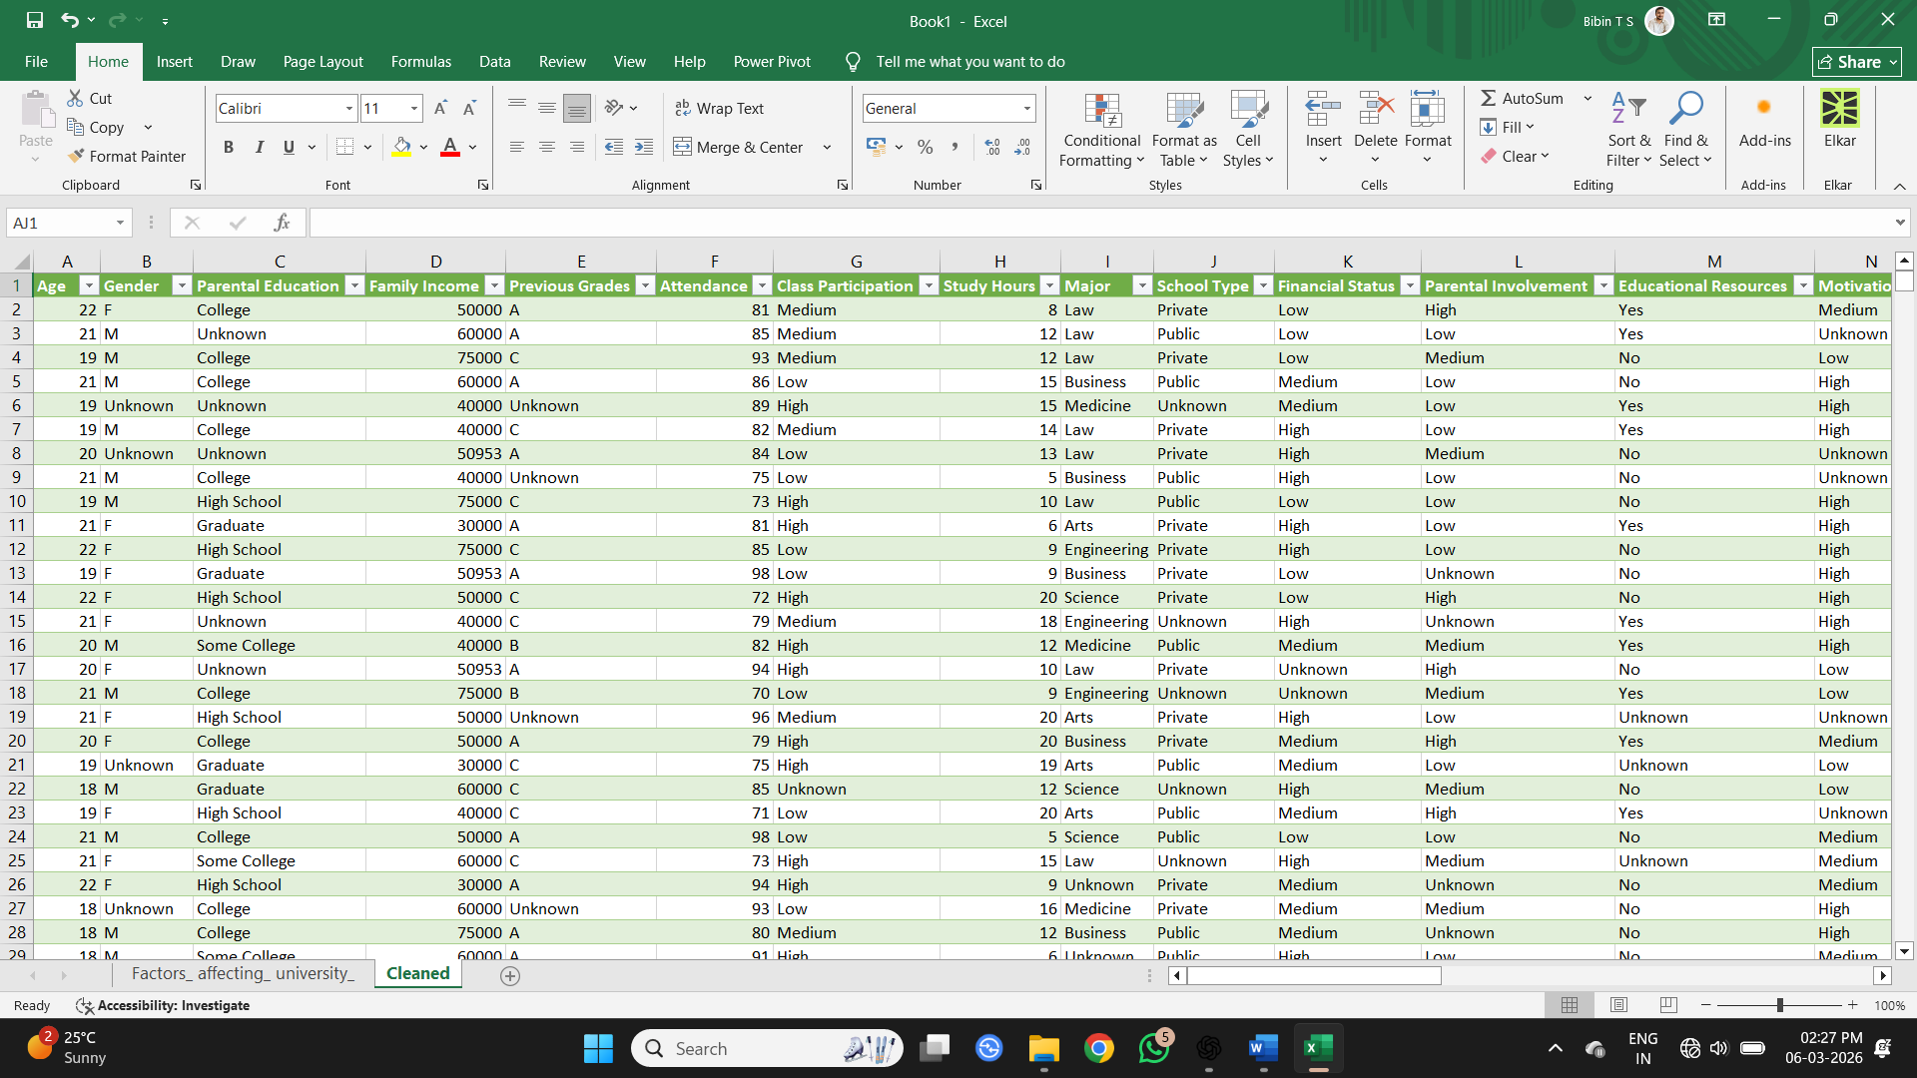
Figure 4 - Handled Missing Values

- Correcting Inconsistent Data
The dataset was examined for inconsistent values using Excel’s Find and Replace feature. No inconsistencies were found in these fields, indicating that the categorical data was already standardized.
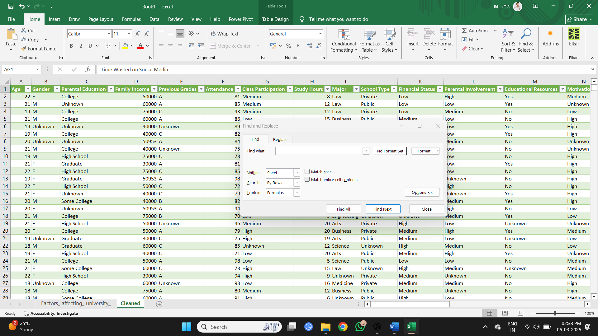
Figure 5 - Checking Inconsistent Data
- Data Transformation
Two new categorical columns were created to support analysis of factors affecting student grades. A Study Hours Category column was generated to group students based on study time into Low (5–9 hours), Medium (10–14 hours), and High (15–20 hours) levels. Similarly, an Attendance Category column was created to classify attendance into Average (70–79%), Good (80–89%), and Excellent (90–100%) groups. These transformations help simplify comparisons between study habits, attendance levels, and student grade outcomes during the analysis stage.
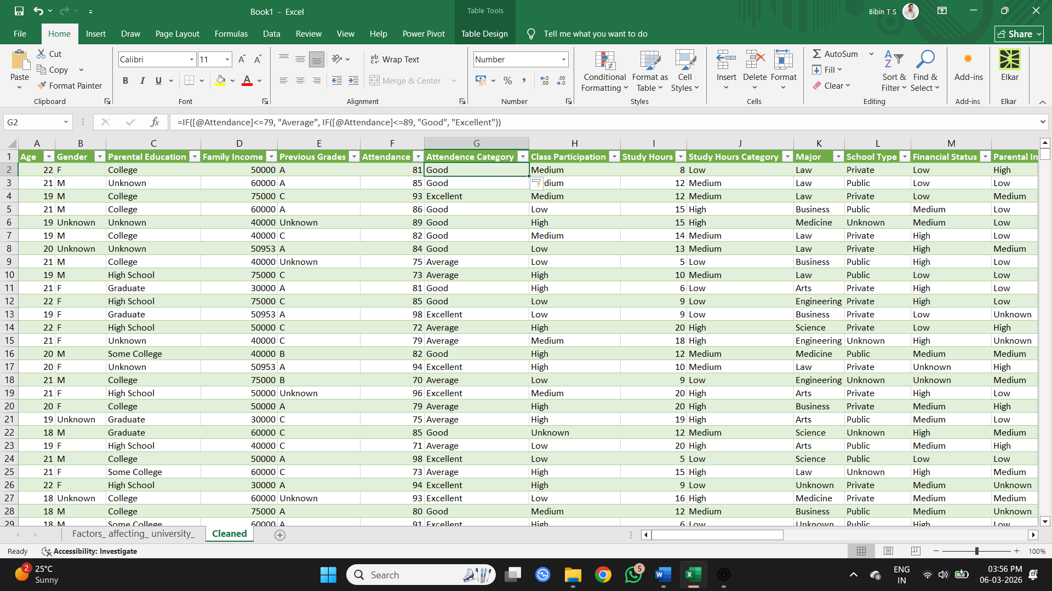
Figure 6 - Created Two Categorical Columns

- Sorting and Filtering
Sorting and filtering tools were used to review the dataset and verify that the cleaned and transformed data was accurate and properly organized before proceeding to the analysis stage.
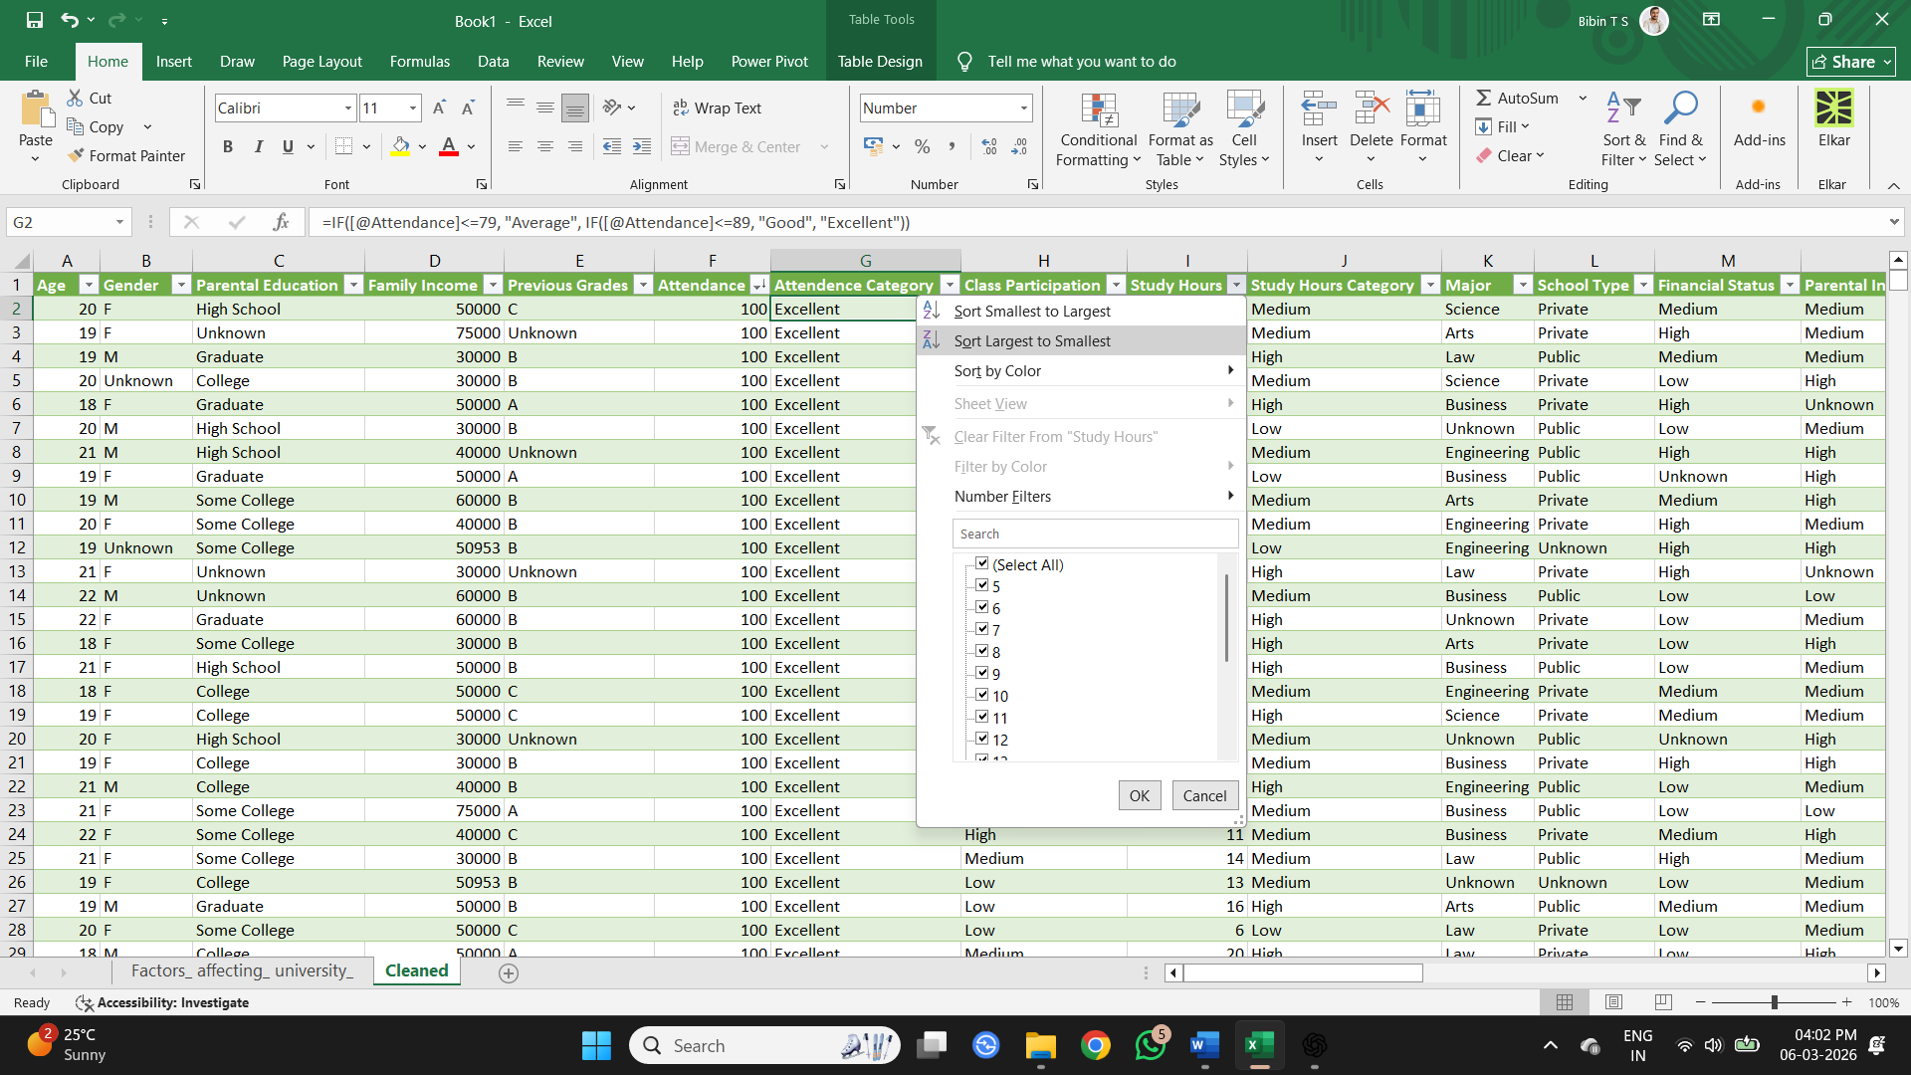
Figure 7 - Sorting and Filtering Data to Verify

DATA ANALYSIS AND VISUALIZATION USING POWER BI
After completing data preprocessing in Excel, the cleaned dataset was imported into Microsoft Power BI for further analysis and visualization. Power BI was used to create calculated columns and visualizations to analyse the factors influencing student academic performance.

- Calculated Columns Using DAX
Calculated columns were created in Power BI using DAX to summarize multiple related variables into key analytical factors. These include Academic Progression, Healthy Lifestyle, Academic Environment, Student Wellbeing, Learning Engagement, and Digital Behaviour, which help analyse different factors influencing student academic performance.
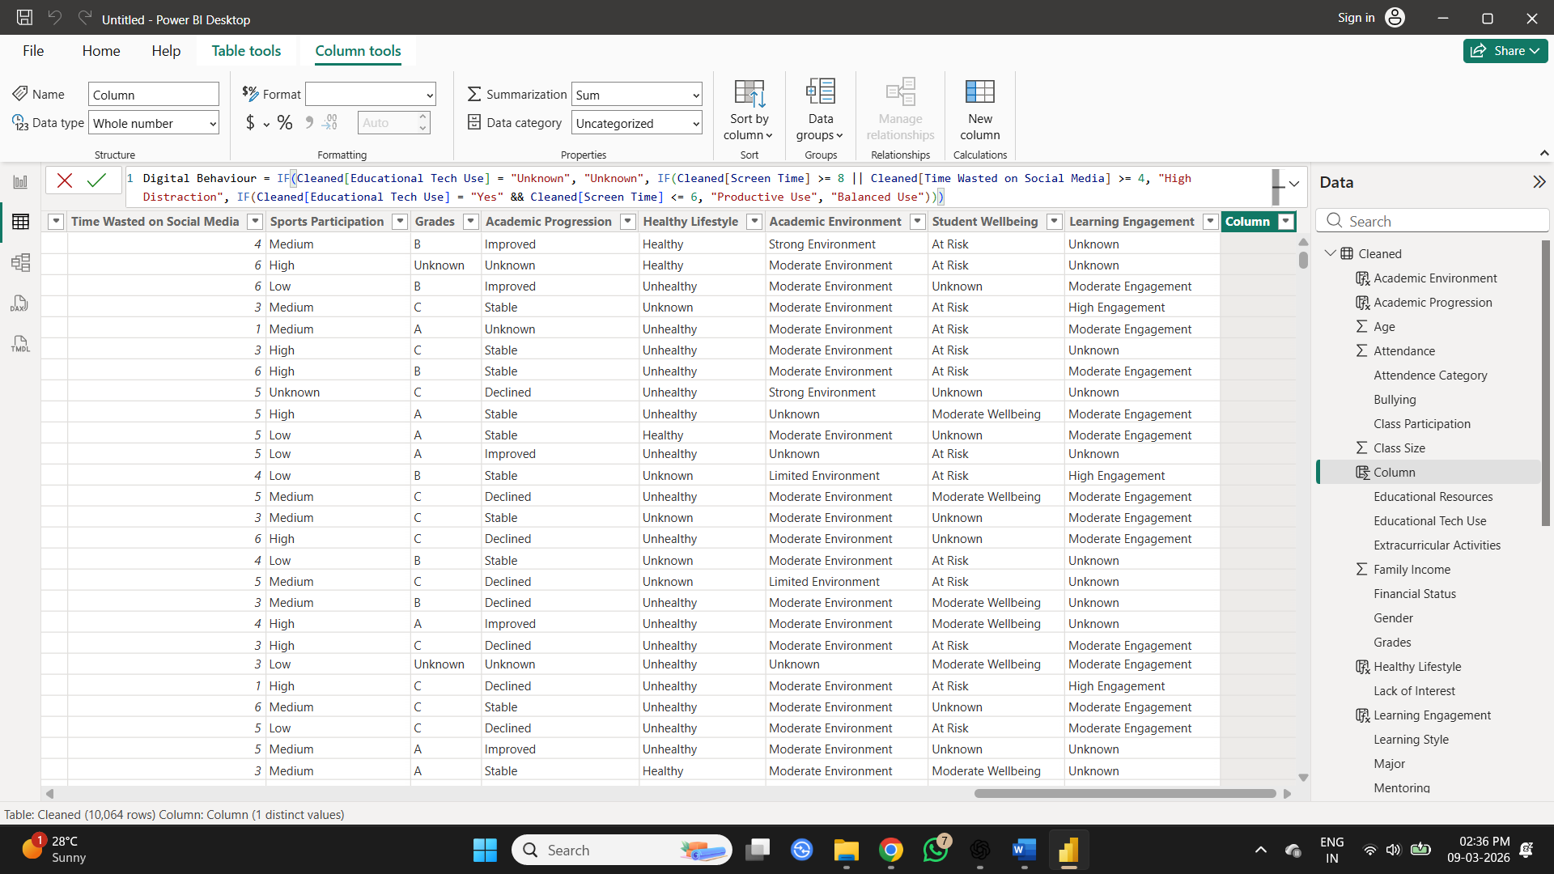
Figure 8 - Creating Calculated Columns

- New Table Creation
A new table was created using SELECTCOLUMNS function to include only the essential columns required for analysis and visualization in the dashboard.
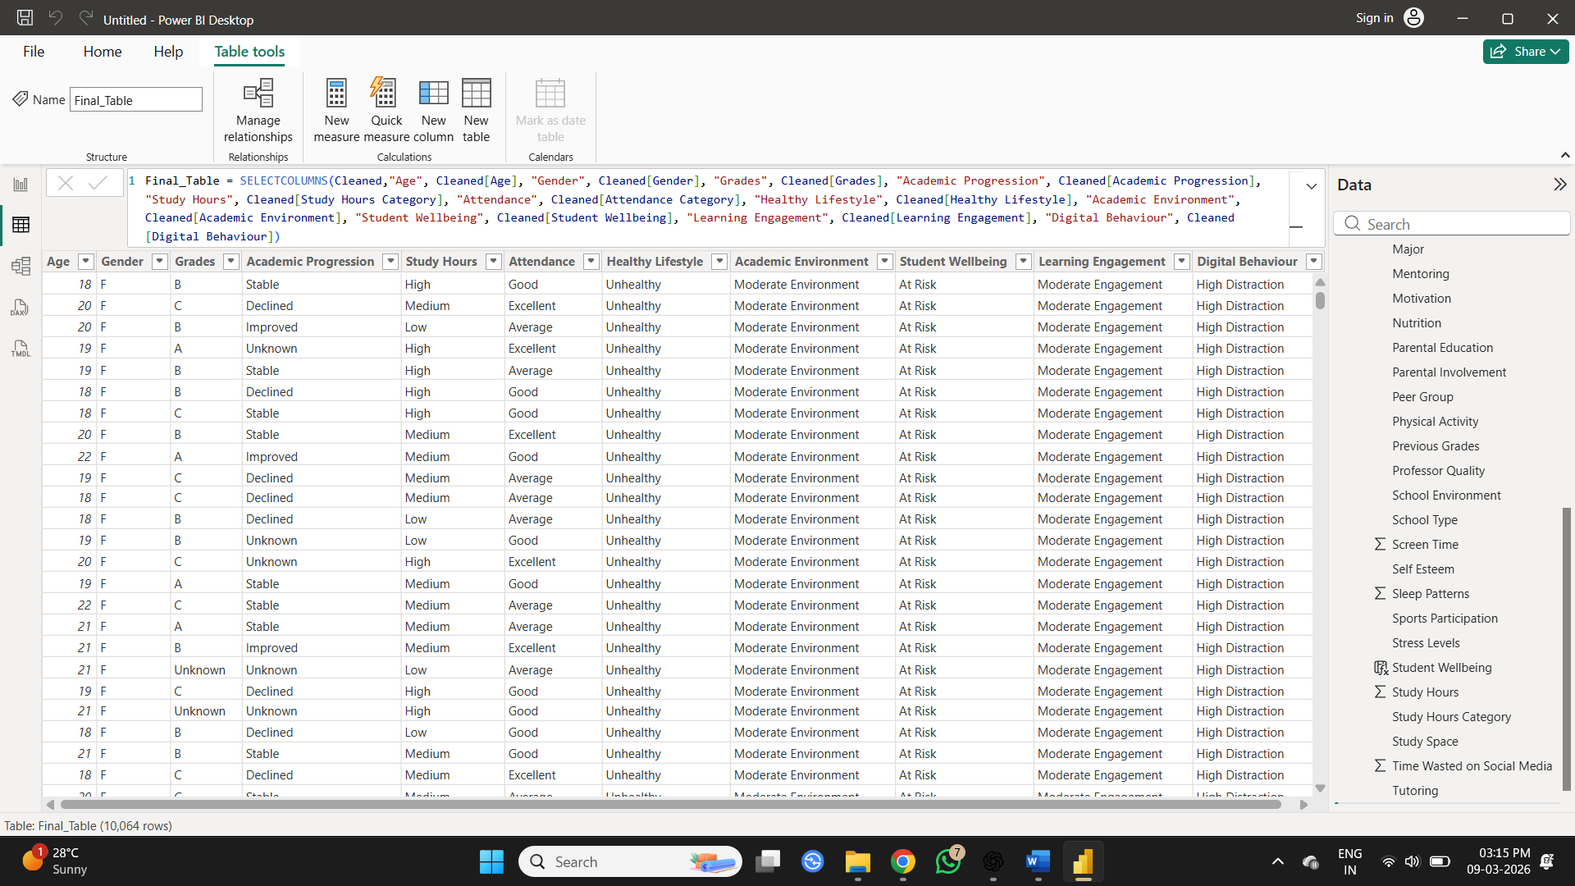
Figure 9 - Creating New Table

- Creating Measures
A few measures were created using New Measure tool to calculate the total number of students and the distribution of grades, which support the dashboard visualizations.
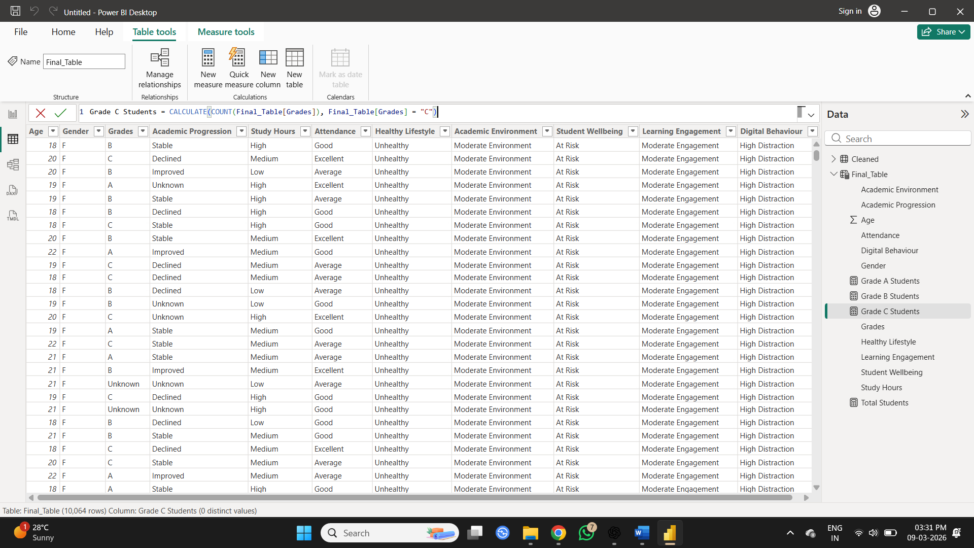
Figure 10 - Creating Measures

- Data Visualization and Dashboard Creation
Various charts such as bar and column charts were created to compare factors like digital behaviour, academic progression, learning engagement, healthy lifestyle, academic environment, and student wellbeing with grades. Card visuals were added to display summary values such as Grade A Students, Grade B Students, Grade C Students, and Total Students. Slicers for Attendance, Study Hours, Gender, and Age were added to enable interactive filtering. The dashboard allows users to interactively explore how different factors influence student grades using slicers and visual comparisons.
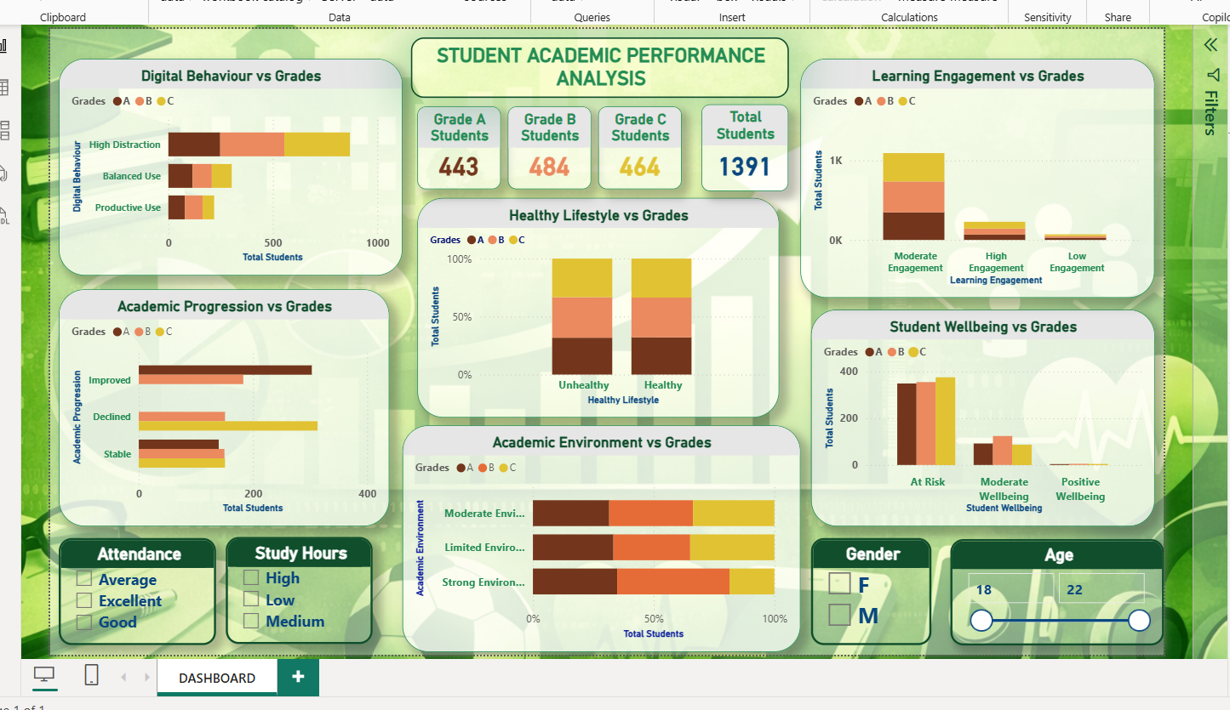
Figure 11 - Visualization and Dashboard Creation

KEY INSIGHTS
- Students with higher study hours and better attendance tend to achieve higher grades.
- Learning engagement shows a positive relationship with academic performance.
- Academic environment also shows variation in student grade distribution.
- Students with healthier lifestyles show relatively better academic outcomes.
- Digital distraction appears to negatively influence student performance.
- Age and gender show relatively small differences in grade distribution.

CONCLUSION
This project analyzed university student data to understand the factors influencing academic performance. Using data preprocessing, transformation, and visualization techniques, several factors such as study habits, lifestyle, academic environment, engagement, and digital behaviour were examined in relation to student grades. The Power BI dashboard provides a clear and interactive view of these relationships, helping to identify patterns that affect student academic outcomes.

